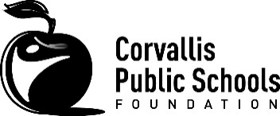
Learning Enrichment Grant Final Report

2015-16 Grant Cycle

Please send completed form by May 15, 2016 to:

liv.gifford@corvallis.k12.or.us

Staff name:

School:

Project Title:

1.
Is the grant complete? Describe the results of your grant project.
2.
How did you measure or evaluate the success of the grant project?
3.
Identify activities that are the result of the grant project which will continue into the future.
4.
Please share a story from the project.

5.
Do you have photos from your project that you would be willing to share with Foundation staff? Please attach.

