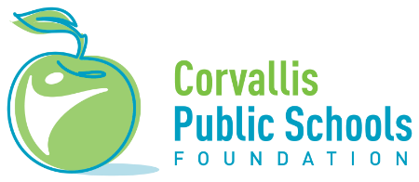
CHS Class of ‘58 Vocational or Technical Training
Scholarship Application

The CHS Class of ’58 Vocational or Technical Training Scholarship, established in 2021, is intended to encourage and support students pursing vocational or technical training after high school. The scholarship is a nonrenewable $1,000 award given through the Corvallis Public Schools Foundation. Funds may be used for tuition, fees, books, supplies, and other related expenses and are paid to the student’s account at their training program.

Qualifications: This scholarship is awarded to a graduating high school senior from Corvallis High School. Applicants must have plans to enroll in an accredited vocational or technical training program that leads to a certification in a trade or service. Applicants must have a minimum 2.5 high school GPA. Students participating in community service, working part-time, or experiencing financial hardship may receive added consideration.

Application:
- Cover Sheet - Complete the cover sheet with your name, address, telephone number, e-mail, and the college or university that you plan to attend.
- Personal Essay: Please tell us about your background, interests, and goals and how this scholarship would help in your career development.
- Letter of Recommendation – Include a letter from a teacher, counselor, or other school staff member who knows you well. Letters from community members will also be accepted.
- Transcript (official or unofficial)
Deadline is April 15th. Application should be sent to the Corvallis Public Schools Foundation, 1555 SW 35th Street, Corvallis, OR 97333 or emailed to admin@cpsfoundation.org.
Note: If you are selected to receive this scholarship, the Corvallis Public Schools Foundation will contact you with instructions for obtaining proof of your enrollment in your selected program.
Completed applications must be received no later than April 15th to be considered.
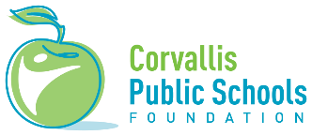
Scholarship Application Cover Sheet
Date:

Scholarship applied for: CHS Class of ‘58 Vocational or Technical Training Scholarship
The Vocational or Technical Program you plan to attend:

Your Legal Name:

Preferred Contact Methods (circle them): e-mail mail phone
Home/Mailing Address:

E-mail:
Daytime Phone:

Please complete and return with other required materials to Corvallis Public Schools Foundation at the address below.

